

**ONLINE SHOP**

**Software Design Document**

– Hanoi, May 2022 –

**Table of Contents**

I. Overview 3

1. Code Packages 3

2. Database Table 4

II. Code Designs 5

1. Class Diagram 5

2. Class Specifications 5

# I. Overview

## 1. Code Packages/Namespaces

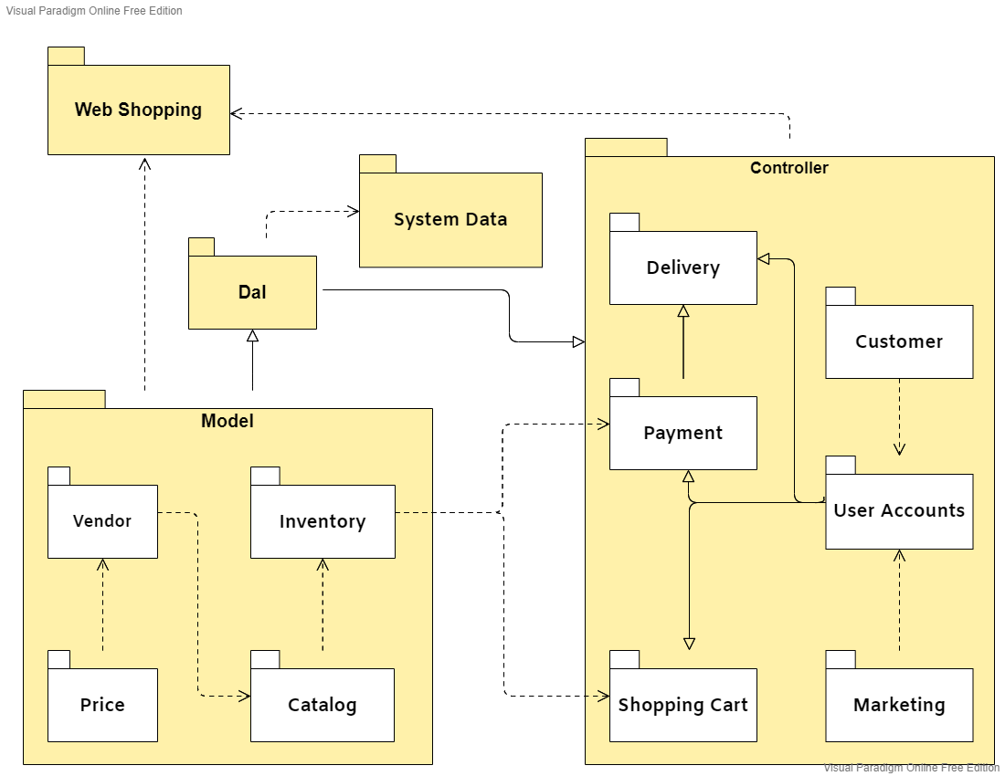

***Package descriptions & package class naming conventions***

|  |  |  |
| --- | --- | --- |
| **No** | **Package** | **Description** |
| 01 | Model | Contains objects |
| 02 | Controller | Connect to the server and execute the logic, for example: Sliders List , Products List , User Profile , Users List , Change Password , Customers List , Product Details , Customer Details , Orders List |
| 03 | Dal | Execute logic, execute sql statement to get data from database , for example : Add , edit , delete …. |
| 04 | System Data | Database for System |

## 2. Database Table

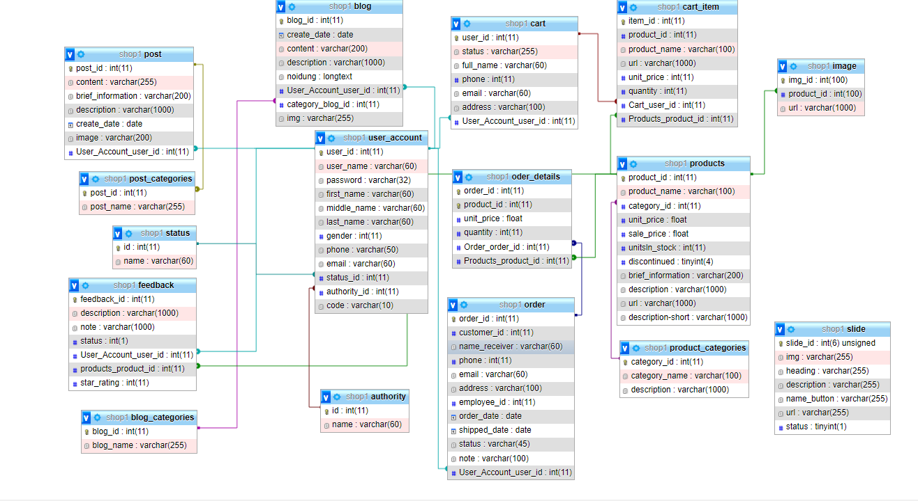

# II. Code Designs

### 1. Class Diagram

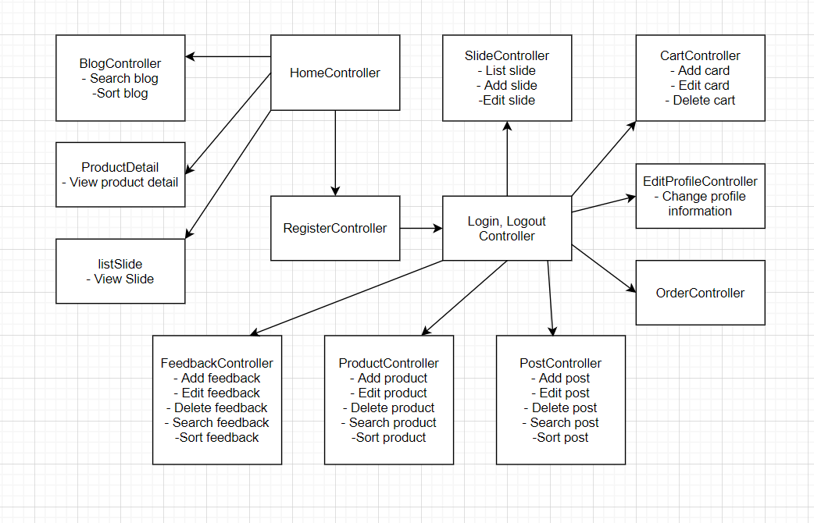

### 2. Class Specifications